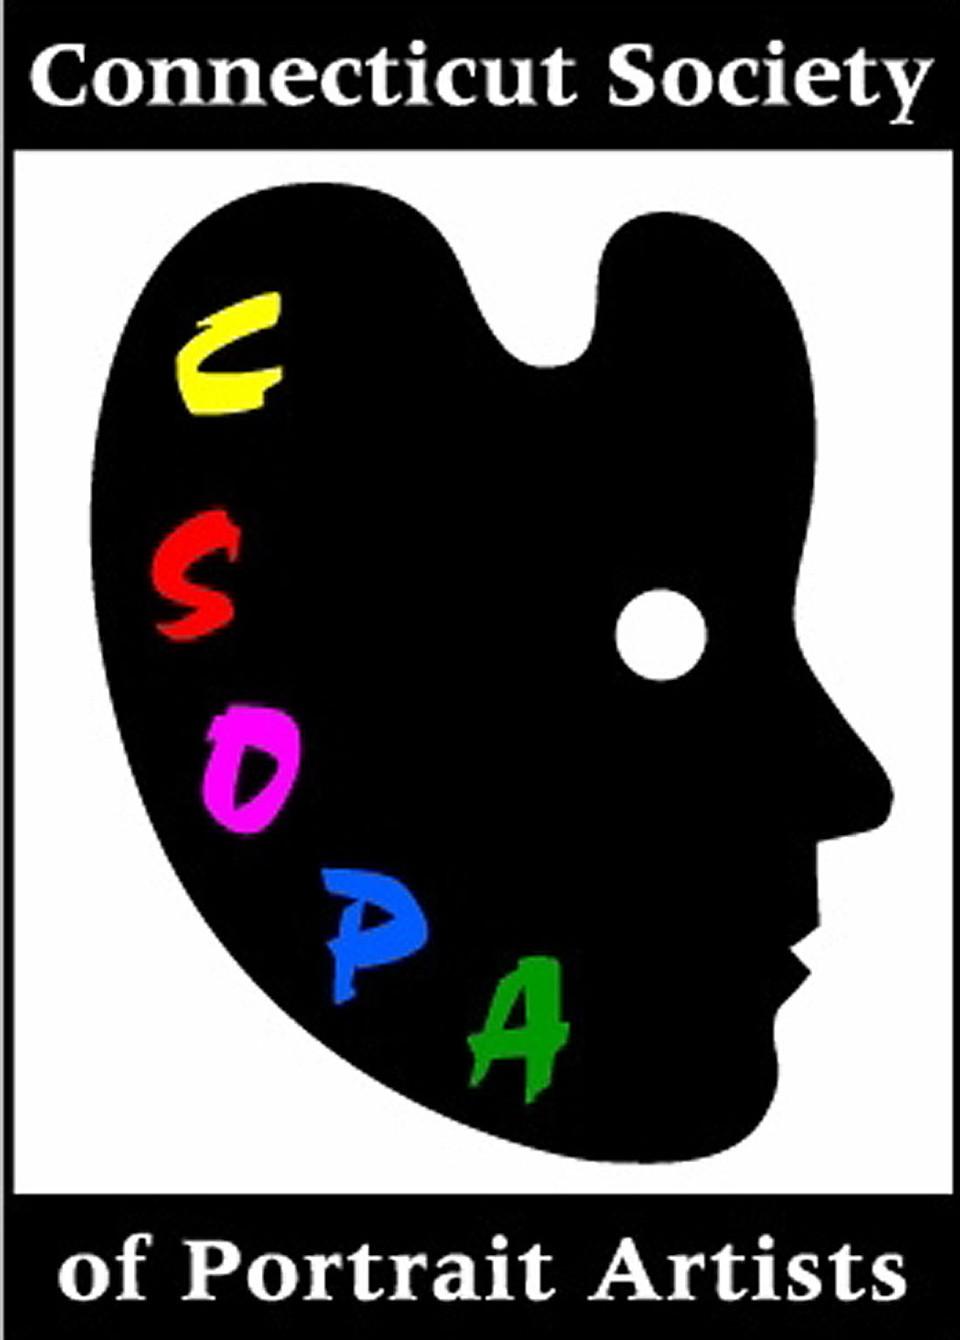
PRESS ANNOUNCEMENT

Release date: April 11, 2006

Attention: Arts Editor/Post-Event Review

Subject: Faces of Spring 2007 – The Results!

CSOPA Contact:
Regional Leader and FSp07 Co-Chair Diane Aeschliman, Diane Aeschliman@aol.com
Web Site reference with event details and photos of all winning portraits: www.csopa.org

Faces of Spring 2007 – The Results!

The Connecticut Society of Portrait Artists in collaboration with The Lyme Art Association have staged their second, juried, biannual Faces of Spring Portrait Festival. Sixty two portraits were selected from a record number of submissions by area artists and judged by the distinguished portrait master Aaron Shikler. Awards were presented at the well-attended opening March 23, 2007. Numerous portrait events round out the month-long festival including workshops with Diane Aeschliman and John Kilroy, Movie Night, and a Paint-In featuring four models in the LAA Galleries. Visit www.CSOPA.org for details.

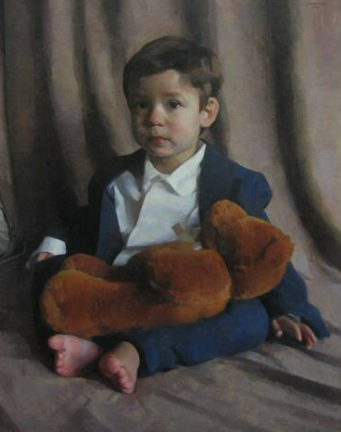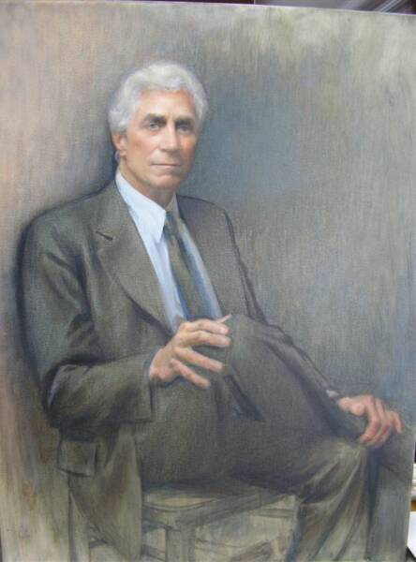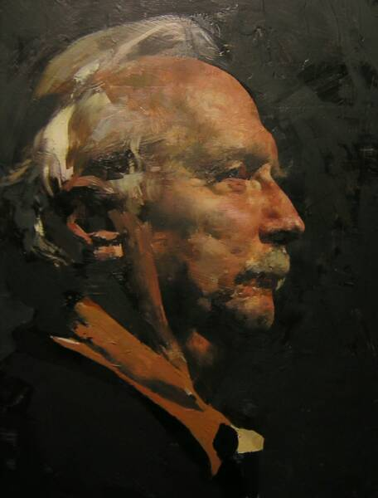

First Place
Jack Montmeat for Victor
Second Place
Elizabeth Noble for Richard F Gereg
Third Place
Hollis Dunlap for Jay

Honorary Mentions
Diane Aeschliman for Kate
Burgess Russell for Elliot
David Luchak for Jim and Lucky
Kelly Birkenruth for Elle
Shin Young An for Riverside
Terence McManus for Bahama Man
Paul Batch for Eric
Jerry Weiss for Claudia
Alice Sue Chism for Cerebral

Merit Awards
Jeff Damberg for Jamie
Jim De Cesare for Kelly Reading
Alain Picard for Dreamer
Shin Young An for Tom

