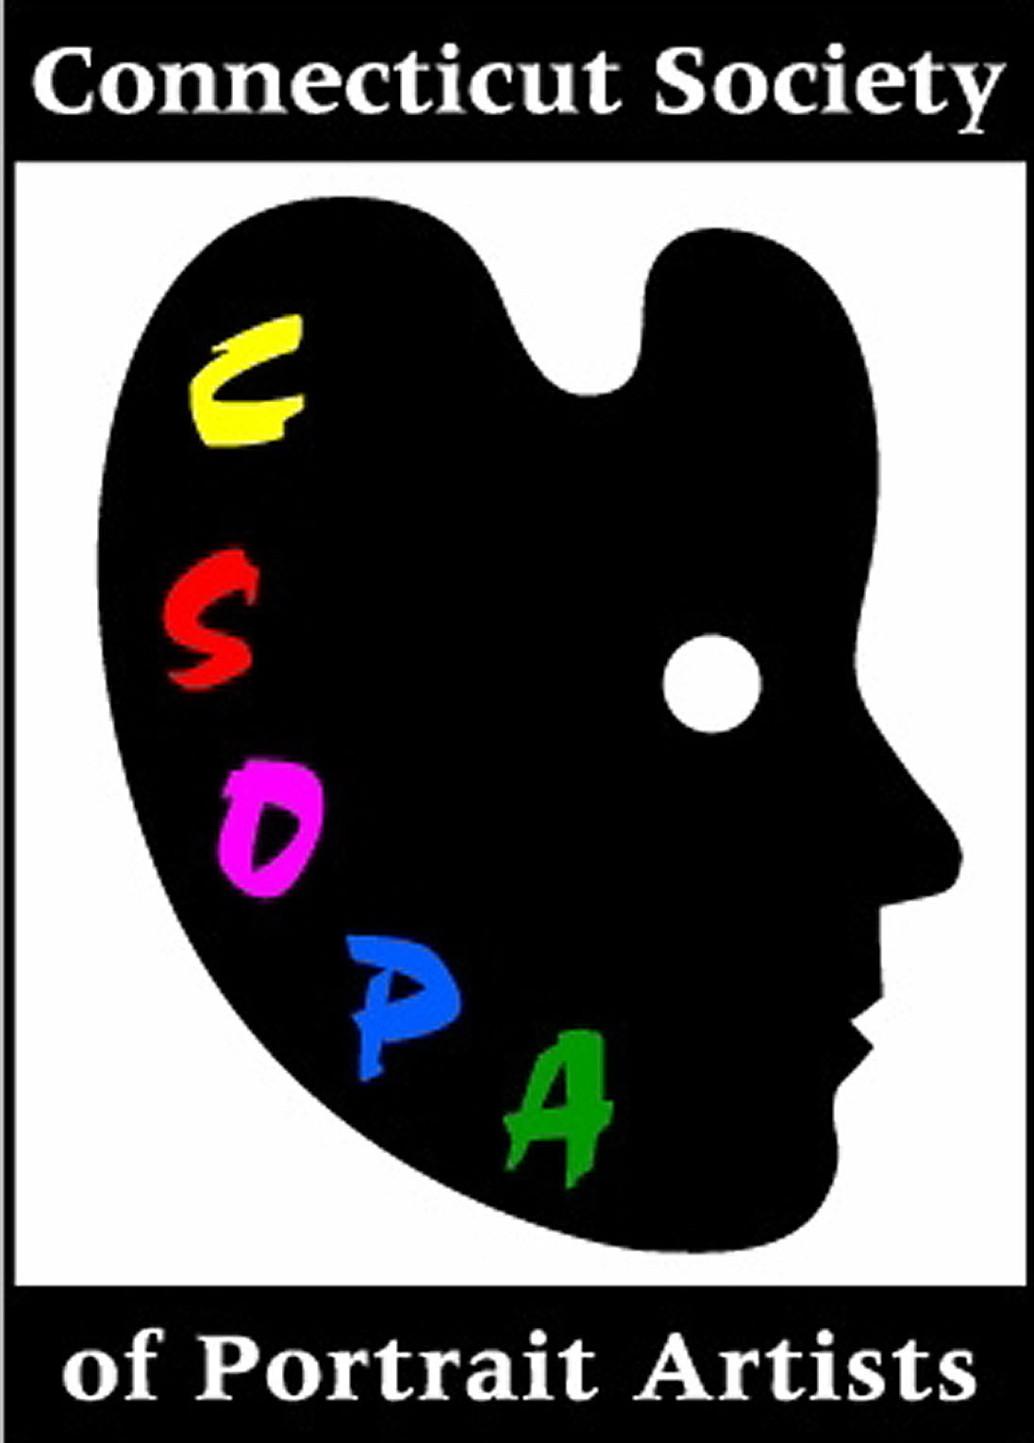
PRESS ANNOUNCEMENT
Release date: April 12, 2006

Attention: Arts Editor/Current Event Calendar

Subject: Portraits to the Avenue

CSOPA Contact: Jeanine Jackson, JacksonPortraits@aol.com, 203-845-9031; Details and more images on: www.csopa.org
GAC Contact: info@greenwicharts.org

Portraits to the Avenue

This May, The Connecticut Society of Portrait Artists (CSOPA) celebrates Arts to the Avenue with two special events at The Greenwich Arts Council (GAC), 299 Greenwich Avenue. Who Will Paint Your Portrait? is a panel discussion on Saturday, May 12, 6:30 to 8:30pm in the second-floor Meeting Room. CSOPA Co-Chair Cindy Wagner moderates comments from successful portrait artists Daniel Duffy of New York City and Greenwich, Jeanine Jackson of Silvermine, Nancy Stember of Westport, and Sandra Wakeen of Somers, CT. Topics include how to select an artist, when to consult a portrait broker, costs and common procedures. Panel artists will have samples in a variety of painting styles and portfolios for review. Anyone wishing like to learn more about the process of commissioning is encouraged to attend. Learn what to look for and questions to ask. Snacks and beverages provided by CSOPA volunteers. $10/$5 for CSOPA and GAC Members is payable at the door. Reserve online at www.CSOPA.org.
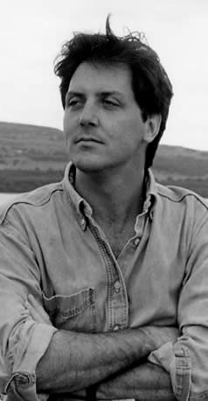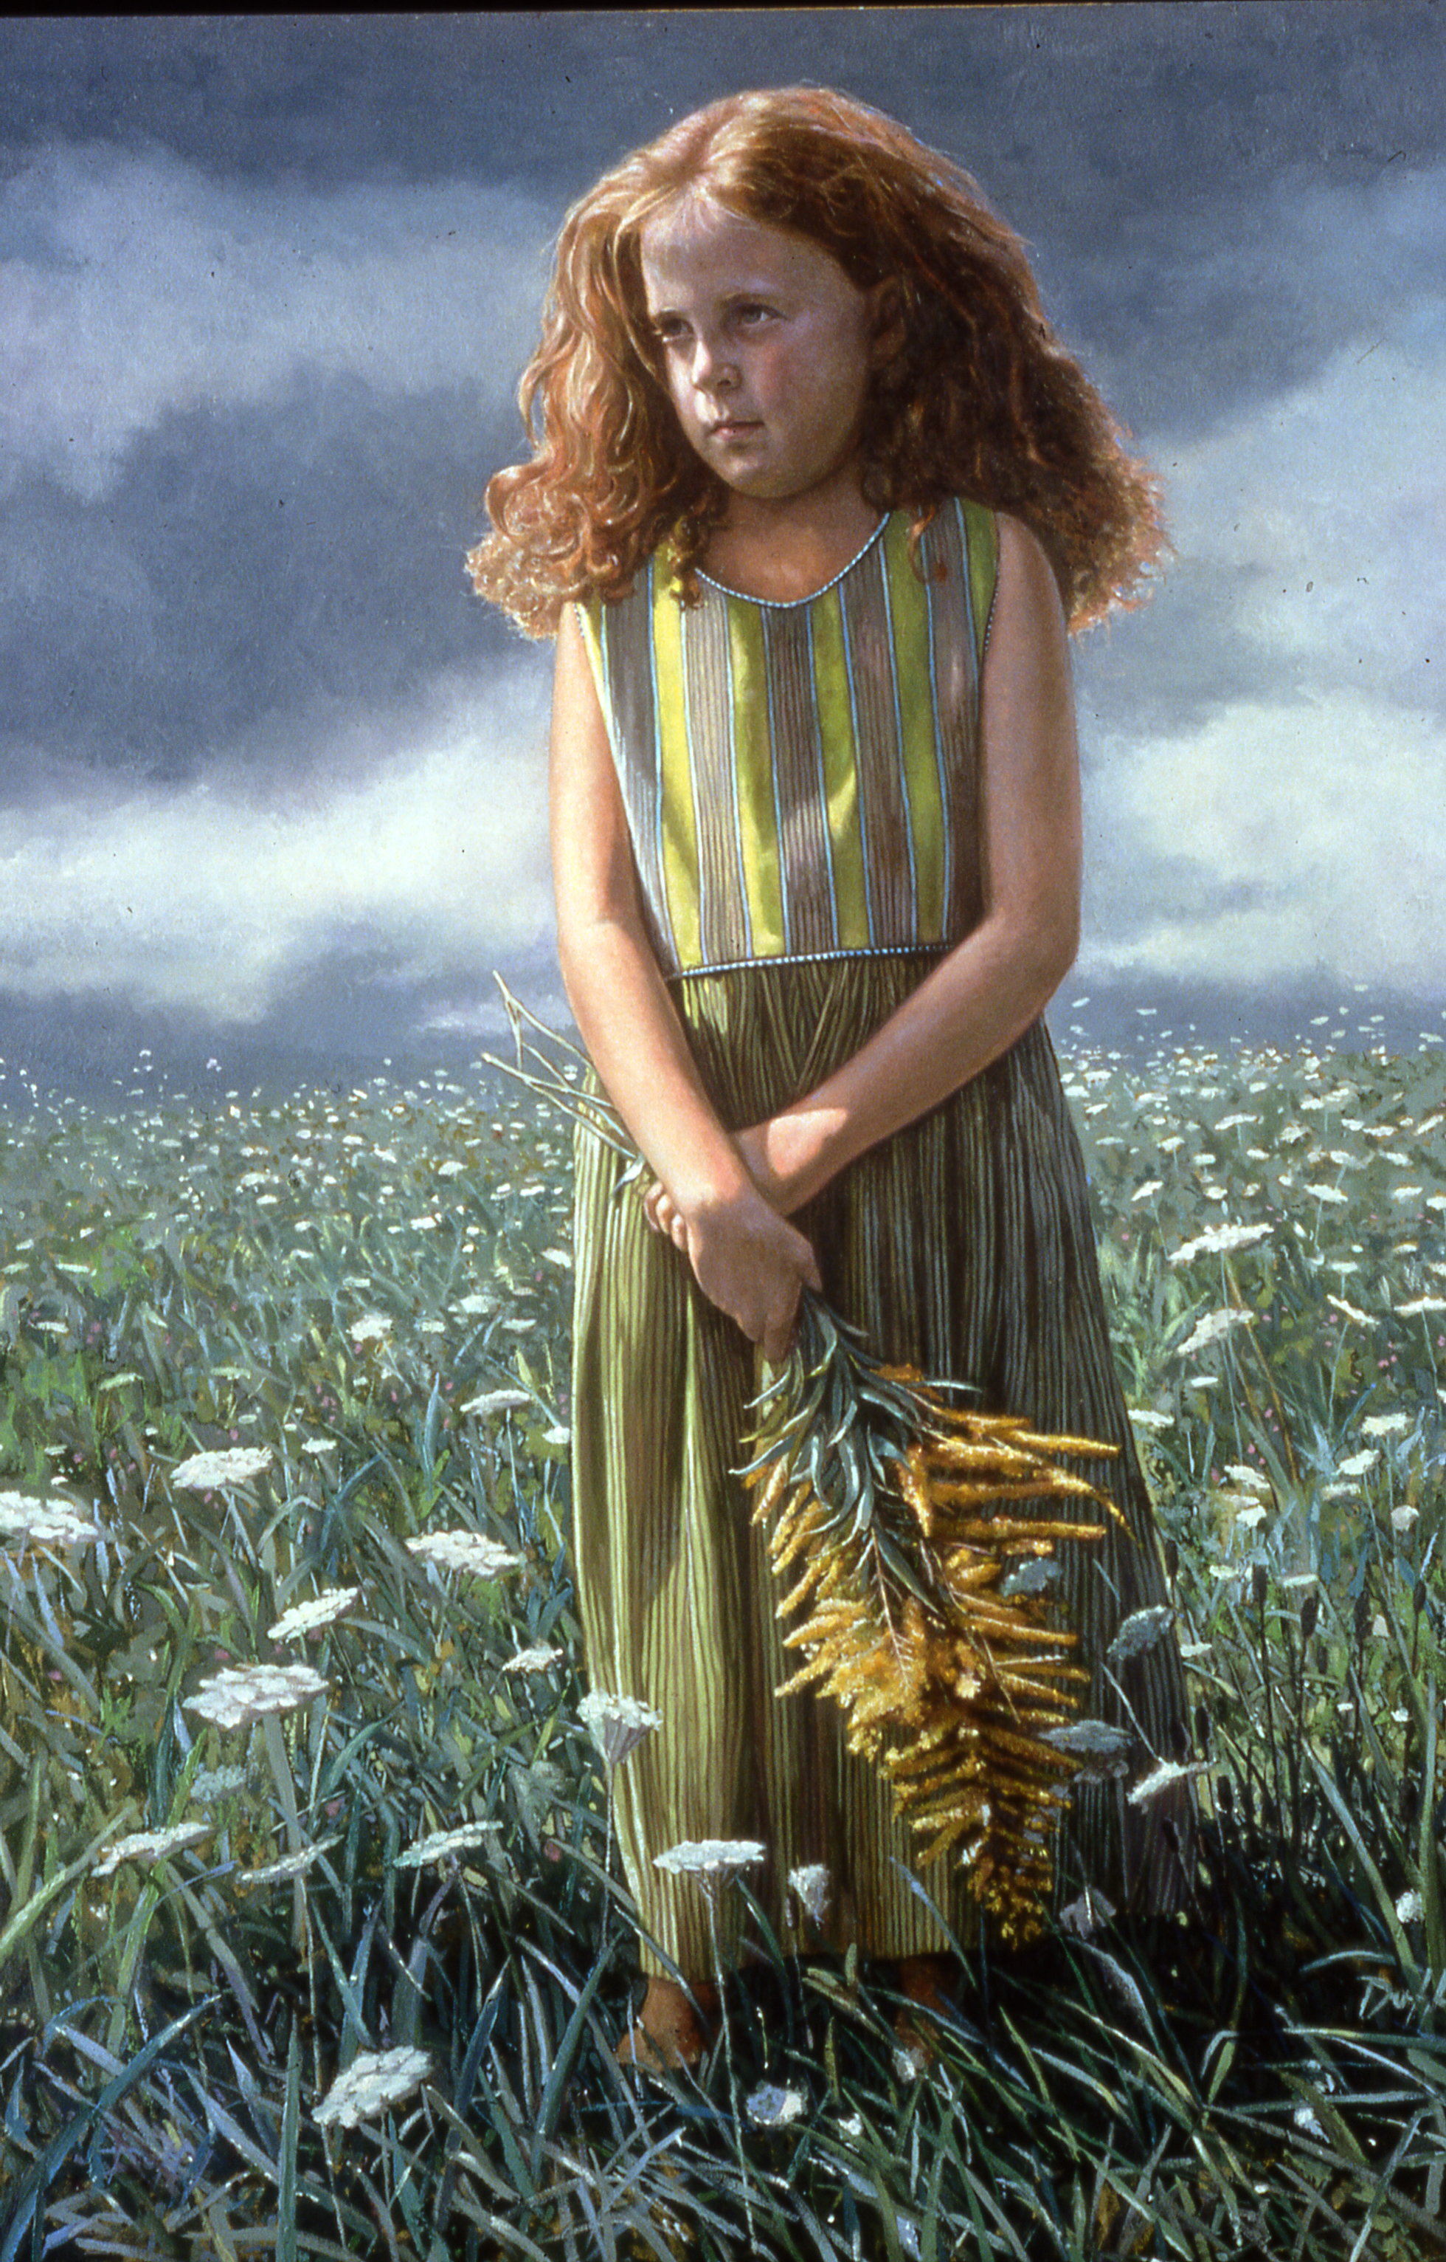
Daniel Duffy and his portrait, Marianna

Then, on Sunday May 20, 1 to 3pm it’s Portraits to the Avenue – literally! Live sketches by several of CSOPA’s finest artists working in graphite, charcoal, pastel, and oil will be available to passers-by in front of the GAC building. In the event of rain, portrait sketches will be done indoors. “It’s a great way to share what we do with the public,” observes CSOPA Founder and President Emerita, Jeanine Jackson. $50 per half-hour sitting. Details on www.CSOPA.org.
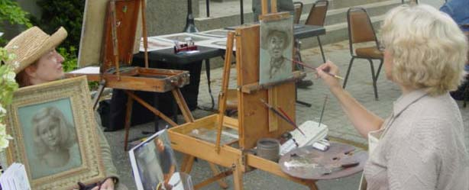
Jeanine Jackson executes a rapid oil sketch of Gretchen Tatge from Old Greenwich in front of The Greenwich Arts Council. Samuel D’Ambruoso from Middlebury sketches a Greenwich resident with graphite.
