The Connecticut Society of Portrait Artists Presents
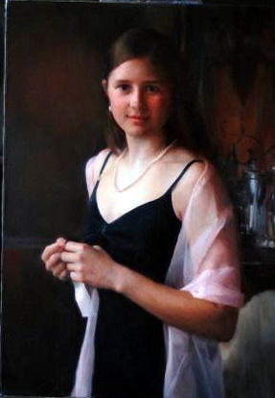
Mary Minifie Portrait Workshop

Mary Minifie is a professional portrait painter and modern master of the Boston School. She attended Wellesley College, Boston University School of Fine Arts, graduate school in painting and spent many years studying portraiture with Boston School painter, Paul Ingbretson. She is represented by Vose Galleries, Boston; The Guild of Boston Artists, Boston; Portraits North, Lexington, MA; Portraits, Inc, New York; Portrait Brokers of America, Birmingham.
The 3-day workshop will focus on painting a model from life in natural light. Emphasis will be on the beauty of the flesh color notes in the natural light and understanding the form of the head. The workshop will begin with setting up a live model with good light and color, finding a composition with interesting clothing and creating a small color study of the whole painting in preparation for the finished work and also suitable for presenting to clients when a commission is underway. The remaining time will include a demo by Mary Minifie and painting time. One lunch time will be used to discuss business angles of the portrait business. There will be a slide lecture and final critique session which can include work not done in the workshop.

For more information www.csopa.org or email csopcietyopa@aol.com Please put Minifie Workshop in subject. Questions to Cindy Wagner: (203) 454- 0280
Visit Mary Minifie’s website to view some more of her spectacular paintings. http://www.maryminifie.com/portraits.htm

Dates: September 19, 20, 21 (Friday-Sunday) 2008, 9:30 – 5pm each day
The Darien Arts Center 2 Renshaw Road Darien, CT
-----------------------------------------------Clip and Mail------------------------------------------------------------

Name:____________________________________

Email Address______________________________

Phone Number_______________________________

Home Address_________________________________

Fee $250 for CSOPA members and Darien Arts Center Member
$285 if you are not a member
Check made out to CSOPA please mail to CSOPA c/o M Delafontaine
29 Legendary Circle
Rye Brook, NY 10573

