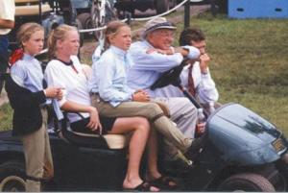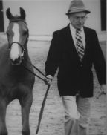
EMERSON BURR
1920-2001
Legendary hunter pony trainer Emerson Burr, 81, of Fairfield, Connecticut,
passed away Monday, December 17, 2001. Burr was best known for his talent
for matching kids to ponies and was known to many as a "father figure" in
the pony hunter ring. His dedication to ponies and the children that show
them lead USA Equestrian and its Pony Committee to name the trophy given to
the trainer of the Overall Grand Hunter Pony Champion at Pony Finals, the
Emerson Burr Perpetual Trophy awarded for the first time in 2000.
In 1965 Burr brought a pony Criban Dart to the Devon Horse Show and Country
Fair. This was his first time showing a pony at the prestigious show and
Criban Dart was declared Champion. This outing set the stage for decades of
blue ribbons, high point riders and ponies, championships and countless
accolades for the legendary Burr, his ponies and the children he took under
his wing.
Burr was the 1999 recipient of the AHSA Lifetime Achievement Award bestowed
annually by the Executive Committee to an outstanding equestrian whose
"lifetime experience and accomplishments exemplify uncommon devotion to the
sport of horse showing and whose equestrian career and horsemanship has
continually elevated the sport's excellence." He was a Chairman Emeritus of
the AHSA Hunter Pony Committee, on which he served through many changes and
served as the host for the first AHSA Pony Finals held in 1967 at the
Fairfield Hunt Club in Fairfield, CT.
